**I z h a n Y a m e e n**

# O B J E C T I V E :

To work in a larger capacity in order to utilize my analytical potential, knowledge and experience of planning & marketing resulting in the establishment and progress of business and my career on strong footings.

# E X P E R I E N C E :

**JOB TITLE COMPANY NAME DURATION WORKING TOOLS**

# C O N T A C T

+92-343-2578695

+92-340-8682605

Ahsang102v@gmail.com

House No:8/3 Street 5 Orangi town Sector 7E Karachi

Queno

Sale Person Women’s Own from Aug 2016 to Nov 2017

Angular, Ionic

Fatima from Dec2017

to jan 2018

phenawa from feb 2018

to Current

AutoCad, Vray SketchUp, MS office

AutoCad, Vray SketchUp, MS office

# E D U C A T I O N

**S K I L L S :**

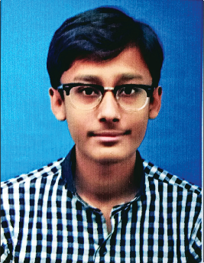

**BASIC :**

Ms Office

English Language (Intermediate)

### PROGRAMMING :

C language HTML5

CSS

Javascript PHP

### GRAPHICS :

Adobe Photoshop Adobe Illustrator AutoCad (civil) SketchUp

Vray (Rendering Engine)

# P R O F I L E :

GitHub https://github.com/izhan25

## INTERMEDIATE

Pre-Engineering, from

Govt. Degree Science College, Ranked : 2nd Division

## MATRIC

Science, from Dehli Grammar Sec. School

# A B O U T M E

Birth Date: 21thAugust1997

Father’s Name: Dilshad Khan Marital Status: Single

City: Karachi

Reference: Will be Furnished

on demand